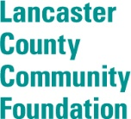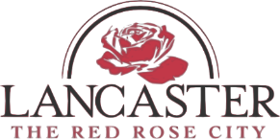
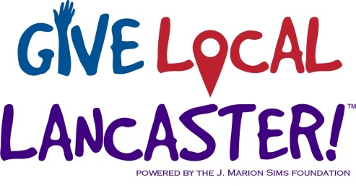
FOR MORE INFORMATION
Name: Susan DeVenny
Email: sdevenny@jmsims.org
Phone: (803) 286-8772
FOR IMMEDIATE RELEASE
Give Local Lancaster 2017
LANCASTER, SOUTH CAROLINA, MAY 1, 2017 – The J. Marion Sims Foundation, Lancaster County Community Foundation, and Partners for Youth in Lancaster County are pleased to announce the 2017 Give Local Lancaster campaign, which elevates the work of local nonprofit organizations and contributes to a healthy and happy community. Give Local Lancaster begins tomorrow, Tuesday May 2, 2017. Donations will be accepted beginning at midnight for 24 hours and can be made online at https://givelocallancaster.org/

QUOTE FROM TYROM FAULKNER, LANCASTER FATHERHOOD PROJECT
This year, 42 nonprofit organizations from Great Falls, Fort Lawn, and Lancaster County will participate, providing plenty of reasons to give.
There are several opportunities for everyone in the community to get involved throughout the day. Five Donation Stations will be available so community members can make contributions in-person. In addition, 18 local businesses will match donations up to nearly $42,000. See the complete list of Donation Stations and local business partners below.
QUOTE FROM DEAN FAILE, LANCASTER COUNTY CHAMBER OF COMMERCE
Lunchtime Dine & Donate Locations:
- The Wagon Wheel in Fort Lawn (5724 Lancaster Hwy, Fort Lawn, SC 29714)
Join the Chester Literacy Council, GRASP and the Fort Lawn Community Center from 11:00 AM- 2:30 PM
- Food trucks at the J. Marion Sims Foundation (800 N. White Street, Lancaster, SC 29720)
Three local food trucks will be parked at the Foundation from 11:00 AM- 2:00 PM
Dinnertime Dine & Donate Locations:
- The Wagon Wheel in Fort Lawn (5724 Lancaster Hwy, Fort Lawn, SC 29714)
Join the Chester Literacy Council, GRASP and the Fort Lawn Community Center from 4:00 PM- 8:30 PM

- Gus’ House of Pizza (101 South Hampton Street, Kershaw, SC 29067) Donate and show your receipt between 5:00 PM- 10:00 PM and free dessert with purchase of meal. Gift certificates will be awarded to the top five donors during this time frame.
- The Craft Stand in Lancaster (134 Main Street, Lancaster, SC 29720) Food catered by Leo’s and live music; $1 from each pint sale will go to a local nonprofit organization. 5:00 PM- 9:00 PM.
- 521 BBQ in Indian Land (Address) *I’ll have to double check times*
Each donor will receive a free tea with food purchase!
Other Partnering Restaurants:
- INSP/ Cross Ridge Café (Address) Free chicken salad combo to anyone with a donor receipt between 11:30 AM – 1:30 PM.
- Chick-fil-A (Address) Free ice cream with donation, all day.

Local Business Partners:
- First Citizens Bank
- First Palmetto
- Crenco
- Lancaster Eye and Laser Center
- Mobley Drugs
- Comporium Communications
- Springs Memorial Hospital
- Nibrol
- Murdock Orthodontists
- Speedy, Tanner, Atkinson & Cook
- Nutramax Laboratories
- Founders
- Rebound
- Perception Builders
- Lancaster County Chamber
- Folks and DeVenny
- Builder’s Supply
- XL MediaWorks, Inc.
###
Give Local Lancaster is the local initiative of Give Local America. Nonprofit organizations across the country have raised over $185 million for thousands of nonprofit organizations since its inception in 2014. To learn more about the Lancaster initiative of Give Local, please visit https://givelocallancaster.org/ or contact GiveLocalLancaster@jmsims.org.
The J. Marion Sims Foundation is entering its third decade of service to the community, with a focus on transforming the health and wellness of Lancaster, Fort Lawn, and Great Falls, SC. For information about the Foundation, please visit www.jmsims.org or contact the Foundation at (803) 286-8772.
The Lancaster County Community Foundation is an affiliate of Foundation For The Carolinas—a philanthropic and charitable services organization serving 13 counties in North and South Carolina, which provides experienced staff, administrative support and fiduciary management. The Foundation brings together charitable donors, community leaders and nonprofit organizations to make positive impacts throughout Lancaster County, South Carolina. To learn more about the Foundation, visit http://www.fftc.org/page.aspx?pid=539 or call (704) 973-4500.
Partners for Youth in Lancaster County is an independent, non-profit partnership built on the generosity of the community, individuals, businesses, and educational institutions of South Carolina. The mission of Lancaster County Partners for Youth, in partnership with community, home, and public schools, is to provide exceptional opportunities that elevate and enrich the children and youth of Lancaster County. To learn more about this organization, visit http://lcpartnersforyouth.org/ or call (803) 286- 1465.

