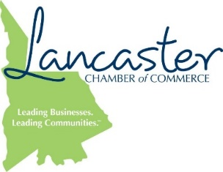

CONTACT: FOR IMMEDIATE RELEASE:
Susan DeVenny MAY 16, 2017
President & CEO
J. Marion Sims Foundation
(803) 286-8772

CHESTER COUNTY CHAMBER OF COMMERCE, J. MARION SIMS FOUNDATION AND LANCASTER COUNTY CHAMBER OF COMMERCE LAUNCHES SUMMER APPRENTICESHIP

Two members from the inaugural J. Marion Sims Foundation summer intern class are returning to the community to serve as apprentices for 10 weeks. Both students will work with the Chester County Chamber of Commerce and Lancaster County Chamber of Commerce. Apprentices will develop promotional videos highlighting local businesses for use in career readiness activities at local schools; design a community internship portal platform to broaden internship opportunities for high school and college students in both counties, and study the concept and possible structure of a young professional’s arm of the Chambers. In addition, they will help train the new intern class and serve in various community needs areas all summer.

The 2017 Community Apprentices are:

Eaven Austin (Lancaster, SC)
A graduate of Lancaster High School, Eaven just finished his sophomore year at Coastal Carolina University. He will complete his degree in Psychology in May 2019. “I am looking forward to this great opportunity to come home and work in the communities of Chester and Lancaster,” said Eaven. “This is so reassuring to have a place within my hometown and there is always work to be done.”

Hannah Knight (Lancaster, SC)
Also a graduate of Lancaster High School, Hannah, a Teaching Fellow at the University of South Carolina- Columbia, has just completed her junior year. She will complete her degree in Middle Level Education in May 2018.

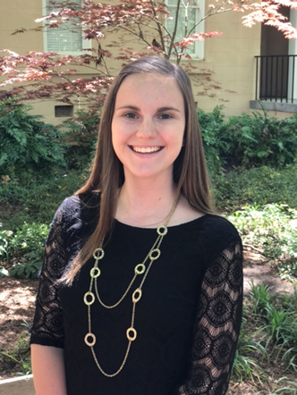

The J. Marion Sims Foundation is also pleased to announce the second class of summer interns. The “Simterns” will begin at the end of May and will work full-time with the Foundation through August. This 10-week paid internship program gives college students the unique opportunity to make important contributions to the community. By working in the field of philanthropy and in partnership with local nonprofit organizations, interns will gain meaningful, real life experiences.

“We’re thrilled to offer college students—particularly those who live in Lancaster and Chester counties— a relevant and meaningful work experience during summer break,” said Susan DeVenny, President & CEO of J. Marion Sims Foundation. “Our Foundation is here to strengthen the health and vibrancy of our community and we know that part of that solution is in our young people.”

###

Chester County Chamber of Commerce
The Chester County Chamber of Commerce is a not-for-profit organization made up of community leaders dedicated to the economic well-being of its members. The Chester County Chamber of Commerce is proud to continue making contributions to the community throughout the County. As we forge the best ideas of business, industry and service organizations into deeds and actions, we will continue to work in harmony with residents, helping to shape our community’s future. Learn more about the Chester County Chamber of Commerce by visiting http://www.chesterchamber.com/.

J. Marion Sims Foundation
The J. Marion Sims Foundation is entering its third decade of service to the community, with a focus on transforming the health and wellness of Lancaster, Fort Lawn, and Great Falls, SC. For information about the Foundation, please visit www.jmsims.org.

Lancaster County Chamber of Commerce
The Lancaster County Chamber of Commerce is a membership based organization that actively works towards progressing successful businesses in Lancaster County. With long term economic vitality in mind, Lancaster Chamber of Commerce builds an opportunity for business networking in the area, designed specifically as a means to grow local businesses and create partnerships. Part of the Chamber’s mission is to enhance the spirit and sense of “community” in Lancaster. As a force of organization, the Chamber enacts coordinative efforts to collaborate and bolster current and future local businesses. To learn more about the Lancaster County Chamber of Commerce, visit http://www.lancasterchambersc.org/.

