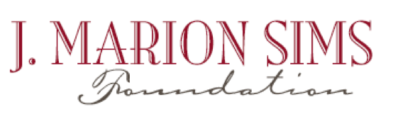
FOR MORE INFORMATION
Name: Susan DeVenny
Email: sdevenny@jmsims.org
Phone: (803) 286-8772
FOR IMMEDIATE RELEASE
J. MARION SIMS LAUNCHES HORIZON EDUCATION GRANT

LANCASTER, SOUTH CAROLINA, January 25, 2017 –The J. Marion Sims Foundation announced the Horizon Education Grant today, a new education grant designed to an enhance teaching and learning and developed to broaden students’ educational journey from 4K– college.
“We have actively supported direct classroom teaching through grants to Lancaster and Chester educators since 2000,” said Robert Folks, Chairman of the J. Marion Sims Foundation Board of Trustees. “The Horizon Education Grant takes our work to a new level: putting healthy community goals front and center and adding youth, families, and higher education partners to the process. We took a pulse of the community last year, including a broad survey of our educators. With a sharper focus on catalyzing healthy and robust communities in 2017, the Horizon Education Grant offer teachers the chance to build the future we all desire for our students.”
Replacing the Teachers’ Pet Grant program, the Horizon Education Grant offers opportunities for student learning inside of the framework of a healthy community, and encourages thinking beyond the traditional classroom. The Horizon Education Grant will initiate collaboration between educators in shared projects and activities. Open to any educator or team of educators in Great Falls, Fort Lawn, and Lancaster County schools, and to educators from the Univeristy of South Carolina Lancaster, Horizon proposals must also incoporate two or more of our community indicators.
“As a teacher, I value collaboration both outside and inside the classroom. A team approach with collegues, parents, and students is the center of an effective and successful education program,” said Lisa Bridges, a teacher at Andrew Jackson High School and J. Marion Sims Foundation Trustee. “The addition of the collaboration components to the Horizon Education Grant will greatly enhance the opportunity to create projects that will be transformational in the classroom and beyond.”
“This new program is intuitive for our educators,” said Vivian Gray, J. Marion Sims Foundation Trustee. “The Horizon Education Grant is an investment in the future for our students and the community as well.”
Applications for the Spring 2017 Horizon Education Grant are due on Wednesday, February 22, 2017. To access an application, or to find more information, visit www.jmsims.org.

###
The J. Marion Sims Foundation is entering its third decade of service to the community, with a focus on transforming the health and wellness of Lancaster, Fort Lawn, and Great Falls, SC. For information about the HORIZON initiative and other programs, please see www.jmsims.org or contact the Foundation at (803) 286-8772.

